Book

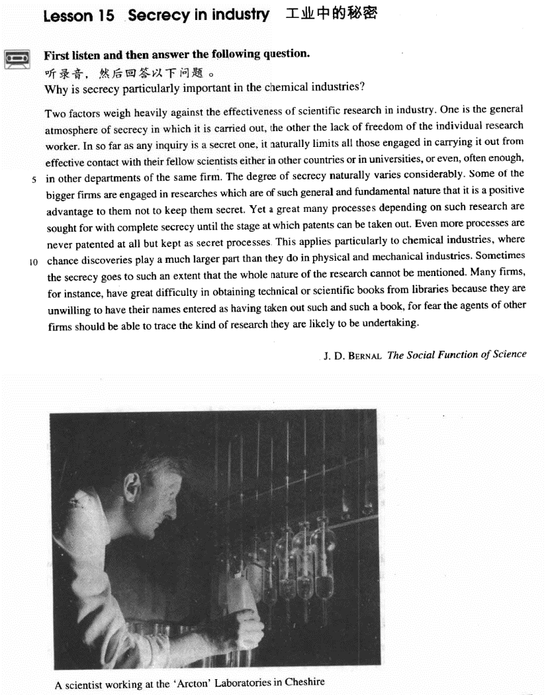

课文

Two factors weigh heavily against the effectiveness of scientific research in industry.

有两个因素严重地妨碍工业中科学研究的效率：

One is the general atmosphere of secrecy in which it is carried out, the other the lack of freedom of the individual research worker.

一是科研工作中普遍存在的保密气氛；二是研究人员缺乏个人自由。

In so far as any inquiry is a secret one, it naturally limits all those engaged in carrying it out from effective contact with their fellow scientists either in other countries or in universities, or even, often enough, in other departments of the same firm.

任何一项研究都涉及到保密，那些从事科研的人员自然受到了限制。他们不能和其他国家、其他大学、甚至往往不能与本公司的其他部门的同行们进行有效的接触。

The degree of secrecy naturally varies considerably.

保密程度自然差别很大。

Some of the bigger firms are engaged in researches which are of such general and fundamental nature that it is a positive advantage to them not to keep them secret.

某些大公司进行的研究属于一般和基础的研究，因此不保密对他们才有利。

Yet a great many processes depending on such research are sought for with complete secrecy until the stage at which patents can be taken out.

然而，依赖这种研究的很多工艺程序是在完全保密的情况下进行的，直到可以取得专利权的阶段为止。

Even more processes are never patented at all but kept as secret processes.

更多的工艺过程根本就不会取得专利权，而是作为秘方保存着。

This applies particularly to chemical industries, where chance discoveries play a much larger part than they do in physical and mechanical industries.

在这化学工业方面尤为突出。同物理和机械工业相比，化学工业中偶然发现的机会要多得多。

Sometimes the secrecy goes to such an extent that the whole nature of the research cannot be mentioned.

有时，保密竟达到了这样的程度，即连研究工作的整个性质都不准提及。

Many firms, for instance have great difficulty in obtaining technical or scientific books from libraries because they are unwilling to have their names entered as having taken out such and such a book, for fear the agents of other firms should be able to trace the kind of research they are likely to be undertaking.

比如，很多公司向图书馆借阅科技书籍时感到困难，因为它们不愿让人家记下它们公司的名字和借阅的某一本书。他们生怕别的公司的情报人员据此摸到他们可能要从事的某项科研项目。

词汇讲解

### secrecy

* **secrecy** ['si:krəsi] n. 保密

**secrecy** n. **英文解释：**keeping secrets, or state of being secret

**in secrecy** / **in secret** / **secretly** 秘密地；私下里做某事

* Many civilians were slaughtered and buried **in secrecy / in secret / secretly**.

**in the secrecy of one’s heart** 某人地内心深处

* The personable young man is Mary’s true love **in the secrecy of her heart**.

**be veiled / shrouded / cloaked in secrecy** 处于机密之中

* The president’s exact itinerary was **veiled / shrouded / cloaked in secrecy** for security reasons.

### effectiveness

* **effectiveness** [ɪ7fek'tɪvnɪs] n. 有效，见效

**【同根词】**

**effective** adj. 有效的，起作用的；实际的，实在的；给人深刻印象

* **take effective** **action** / **measures** / **steps** … 采取有效的…
* a very **effective** ruler

**effectual** adj. 奏效的；会应验的；有法律效力的 （不能指人）

* take **effectual** measures
* an effectual ruler X 错误表达

**【形近词】**

**efficacious** adj. 有效的；灵验的 （用于医学方面）

* an **efficacious** medicine
* Vaccination is **efficacious** in preventing smallpox.

**efficient** adj. 有效率的；有能力的；生效的

* **efficient** methods
* an **efficient** secretary

### inquiry

* **inquiry** [in'kwaiəri] n. 询问，查询；调查，研究

**inquiry** / **enquiry**

* **inquiry** desk

**【辨析】**表达“**调查，研究**”:

**inquiry** （没有场合限制）

* on the spot **inquiry**
* official **inquiry**
* sampling **inquiry**

**inquisition** （非常仔细、严厉的）一连串的提问；（尤指）盘问，责难

* The suspect was pushed toward the edge by the **inquisitions** of the police.

**investigation** n. （案件、事故调查）调查；调查研究

* The case is ***under* investigation**.
* The **investigation *into***the cause of the air crash is continuing.

**inquest** （对死因的调查）

* an **inquest *into***the death of the actor

**research** （学术上的调查研究）

* scientific **research**

### process

* **process**['prəʊses] ['prɑsɛs] n. 过程，进程，步骤； 制作方法，工艺流程

**process**: n. **含义1：**a series of actions that are done in order to achieve a result

过程，进程，步骤

* the **process** of aging 衰老的过程
* the **process** of digestion 消化的过程
* the Middle East peace **process** 和平进程

**process** n. **含义2：**method in industry to make sth. 工业上制做某种产品的方法，工艺流程

* They have developed a new **process** for extracting aluminum from bauxite.

**in the process of doing sth.** 在做某事的过程中

* We’re still **in the process of** moving house.

**process** v. **含义3：**加工，处理

* central **processing** unit (CPU)
* data **processing**

课文讲解

# （第一段）

# Two factors weigh heavily against the effectiveness of scientific research in industry.

知识点（1）

**weigh**

**weigh one’s words**  斟酌词句

**weigh the pros and cons** 斟酌利弊、得失

* We must **weigh the pros and cons** before deciding whether to invest our money.

**weigh with sb.** 对某人来说很重要

* It **weighs heavily with** me.
* = It **matters to** me.
* = It **means a lot to** me.
* = It **makes a lot of difference to** me.

**weigh in one’s favor**  对…有利

* These facts will **weigh in your favor**.

**weigh against …** 对…不利

* The lady’s evidence will **weigh against** him. I’m not optimistic about the verdict.

# One is the general atmosphere of secrecy in which it is carried out, the other the lack of freedom of the individual research worker.

**语法分析：**

One is the general atmosphere of secrecy in which（先行词，指代secrecy） it is carried out（which...定语从句）, *the other****（being）*** *the lack of freedom of the individual research worker（独立主格）*.

知识点（1）

**atmosphere** n. **英文解释：**the mood or feeling that exists in a place and affects the people who are there 气氛

* After Joe left there was a more relaxed **atmosphere** at home.

**atmosphere of …** …的气氛

* There is an **atmosphere of** tension in the city today.

知识点（2）

**语法：**独立主格

One is the general atmosphere of secrecy in which it is carried out, the other ***(being)*** the lack of freedom of the individual research worker.

# In so far as any inquiry is a secret one, it naturally limits all those engaged in carrying it out from effective contact with their fellow scientists either in other countries or in universities, or even, often enough, in other departments of the same firm.

**语法分析：**

**In so far as(因为)** any inquiry is a secret one（原因状语从句）, it naturally ***limits*** all those *engaged in carrying it out* ***from****（后置定语,修饰those）* effective contact *with （后置定语,修饰contact） their fellow scientists either in other countries or in universities, or even, often* ***enough（相当的）****, in other departments of the same firm（后置定语,修饰scientists）*.

知识点（1）

**in so far as …** / **insofar as …**

**含义1：**= **to the extent that …** 在…的范围之内；到达…的程度

* She cites other scholars’ work only **insofar as** it supports her own theories.

**含义1：**= **because** / **since** / **in that**

* He can be trusted **insofar as** he has never told a lie.

知识点（2）

**limit … from …** 使…限制；使…不能

**【****近似词组】**表达“**使…限制；使…不能**”：

**keep … from …**

* His wife **keeps** him **from** alcohol.

**bar / prevent … from …**

* The problem **barred** / **prevent** me **from** completing the work.

**dissuade … from**

* I **dissuaded** him **from** committing suicide.

**prohibit … from …** 禁止…做某事

**ban … from …**  （命令禁止）禁止…做某事

**disqualify … from …** 使…没有资格做某事

* His criminal record **disqualifies** him **from** serving on a jury.

**save / rescue … from …** 拯救…使…免于

**restrain … from …** 阻住…做某事

* Please **restrain** yourself **from** coughing during the performance.

知识点（3）

**keep in contact with sb.** 与某人保持联系

= **keep in touch with sb.**

**contact** 做及物动词

* Please don’t hesitate to contact with me if you have further questions. X 错误表达
* Please don’t hesitate to **contact** me if you have further questions.

# The degree of secrecy naturally varies considerably.

知识点（1）

**vary 表“变化”**

表达“**变化相当大的**”：

**vary** **greatly / widely / significantly / dramatically / enormously / substantially**

表达“**变化小的**”：

**vary** **slightly** / **somewhat**

表达“**在某方面有所不同**”：

**vary** in **size** / **degree** / **length** …

* Rooms **vary in size** but all have television and telephone.

**【词组搭配】**

**vary according to …** 因…而异

* The leaf's size **varies** widely **according to** the area where it grows.
* Every solid object will reflect a sound, **varying according to** the size and nature of the object.

**vary from … to …** 从…到…是不同的

* Tests scores **vary** **from** school **to** school.
* The amount of sleep we need **varies** **from** person **to** person.
* Office hours **vary** **from** company **to** company and country to country.

# Some of the bigger firms are engaged in researches which are of such general and fundamental nature that it is a positive advantage to them not to keep them secret.

**语法分析：**

Some of the bigger firms are engaged in researches which are of **such** general and fundamental nature ***that***（***that***... 引导结果状语） *it（形式主语）is a positive advantage to them not to keep them secret（真正主语）*. （which...定语从句）

知识点（1）Lesson04-03

**语法：of a … nature** 做后置定语，修饰前面的名词；表示“某种类型的…”

* … dangers ***of*** the most perilous **nature** …
* It is true that during their explorations they often faced difficulties and dangers ***of*** the most perilous ***nature***, equipped in a manner which would make a modern climber shudder at the thought, but they did not go out of their way to court such excitement
* I can’t approve of things ***of***this **nature**. 这种事
* treaties ***of***a political nature 政治性的条约
* books ***of***an erotic nature 色情的书刊
* questions ***of***an academic **nature** 学术性的问题
* articles ***of***a technical nature 技术性的文章

知识点（2）

* **课文写法替换：so … that …**
* … which are **so**general and fundamental **that**it is …
* **课文写法替换：**表达“对他们来说最有利的”：
* … it is a **positive advantage to them** not to keep them secret.
* … it is **in their best interests** not to …
* **课文写法替换：**表达“不保密”
* … it is a positive advantage to them **not to keep them secret**.
* … **to keep them open (to the public)**.

# Yet a great many processes depending on such research are sought for with complete secrecy until the stage at which patents can be taken out.

**语法分析：**

Yet a great many processes depending on such research（非谓语动词做后置定语,修饰processes） are sought for with complete secrecy until the stage *at which（which 修饰 stage） patents can be taken out（which...定语从句）*.

知识点（1）

**research** [U] / **researches** [pl.]

* a research X错误表达
* two researches X错误表达

**study** 表“研究”：

* a study √
* two studies √

知识点（2）

**seek** 寻求；寻找；探索；搜索

* **seek** refuge / shelter / asylum
* **seek** revenge
* **seek** comfort

**seek for / after …** 追求…

* **seek for** solutions
* His book is much **sought after**.

知识点（3）

**take out a patent** 取得专利

**apply for a patent**  申请专利

**give / grant a patent** 授予专利

**infringe a patent** 侵犯专利

知识点（4）

* **课文写法替换：**表达“**直到拥有知识产权**”：
* … until the stage at which patents can be taken out.
* … until they own **the intellectual property rights**.

# Even more processes are never patented at all but kept as secret processes.

# This applies particularly to chemical industries, where chance discoveries play a much larger part than they do in physical and mechanical industries.

**语法分析：**

This applies particularly to chemical industries, where chance discoveries play a much larger part *than they do in physical and mechanical industries**（than... 比较状语）*. （where… 非限定性定语从句，看做原因状语从句）

知识点（1）

**apply to …** 适用于

* The rules of safe driving **apply to** everyone.
* The restriction no longer **applies to** him because he is over 18.

知识点（2）

**chance** adj. **accidental** 偶然的

* a **chance** meeting / encounter

**【反义词】**

**deliberate** adj. 故意的

**intentional** adj. 故意的

**【词组搭配】**

**chance** 做动词

**chance / happen to do** 偶然…

* He **chanced / happened to be** out when I called him.

**as chance would have it** 碰巧

= **as luck would have it**

知识点（3）Lesson03-56

**play a … role / part in …** 发挥某种作用

* **造句：**西安市在中国历史上有至关重要的作用。
* The city of Xi’an **played a crucial role in** the history of China.
* **造句：**政府在促进人权方面应该发挥更显著的作用。
* The government should **play a** **more prominent** **part in** promoting human rights.
* Not all sounds made by animals serve as language, and we have only to turn to that extraordinary discovery of echo-location in bats to see a case **in** which the voice **plays a strictly utilitarian role**.
* The fact of first-rate importance is the predominant **role** that custom **plays in** experience and in belief, and the very great varieties it may manifest.
* John Dewey has said in all seriousness that the **part played** by custom **in** shaping the behavior of the individual, as against any way in which he can affect traditional custom, is as the proportion of the total vocabulary of his mother tongue against those words of his own baby talk that are taken up into the vernacular of his family.

知识点（4）知识扩展：**偶然发现**

**Legend has it that（据传说）** the antibiotic penicillin is a chance discovery by British bacteriologist Sir Alexander Fleming.

If I have ever made any valuable discoveries, it has been owing more to patient observation than to any other reason.

— Isaac Newton, English physicist

# Sometimes the secrecy goes to such an extent that the whole nature of the research cannot be mentioned.

**语法分析：**

Sometimes the secrecy goes to **such** an extent that the whole nature of the research cannot be mentioned. （that... 引导结果状语）

# Many firms, for instance have great difficulty in obtaining technical or scientific books from libraries because they are unwilling to have their names entered as having taken out such and such a book, for fear the agents of other firms should be able to trace the kind of research they are likely to be undertaking.

**语法分析：**

Many firms, *for instance**（插入语）*, have great difficulty in obtaining technical or scientific books from libraries because they are unwilling to have their names **entered（登记、记录）** as having taken out such and such a book, ***for fear****（“以免”，复合连词，看做引导目的状语） the agents of other firms* ***should（should do 句型，对应for fear）*** *be able to trace the kind of research they are* *likely to be undertaking**（定语从句）*. （because... 原因状语从句）

知识点（1）

**have difficulty (in) doing sth.**  做某事有苦难

= **have trouble (in) doing sth.**

= **have a hard time doing sth.**

* She **had a hard time** writing the dear John letter.

**【复习】**Lesson04-08

**be hard-pressed to do sth.** 某事太复杂，不大可能成功或发生

**be hard-pressed to do sth. at all** 某事太复杂，**根本**不大可能成功或发生

* Owing to shortage of staff, the emergency services **were hard-pressed to deal with** the accident.
* Although negotiators are optimistic, the details are complex enough that they may **be hard-pressed to** get a deal at all.

知识点（2）Lesson03-48

**be unwilling to do sth.**  不愿意做某事

= **be reluctant to do sth.**

* Though he **was reluctant to do** so at first, we eventually persuaded him to take us.

= **be disinclined to do sth.** （更正式）

* I **was disinclined to** talk to him about it.

= **be indisposed to do sth.** （更正式）

* He **seemed** somewhat **indisposed to** depart. be willing to do sth.

**【反义词组】**表达“**愿意做某事**”：

**be ready / prepared to do sth.**

**be inclined to do sth.**

**be disposed to do sth.**

知识点（3）

**take out** **含义1：** borrow books from a library 从图书馆借书

* You can **take out** six books at a time.

**take out 含义2：** obtain an official document 获得政府正式文件

* **take out** an insurance policy / a mortgage / a patent
* They find a house, agree a price, and **take out** a mortgage.

知识点（4）

**such and such** **a** 某某

* **such and such a** person
* **such and such a** place

知识点（5）

**for fear (that) …** （正式）以免、以防（引导目的状语）

**in case (that) …**

* I daren’t tell you what he did, **for fear that** he should be angry with me.